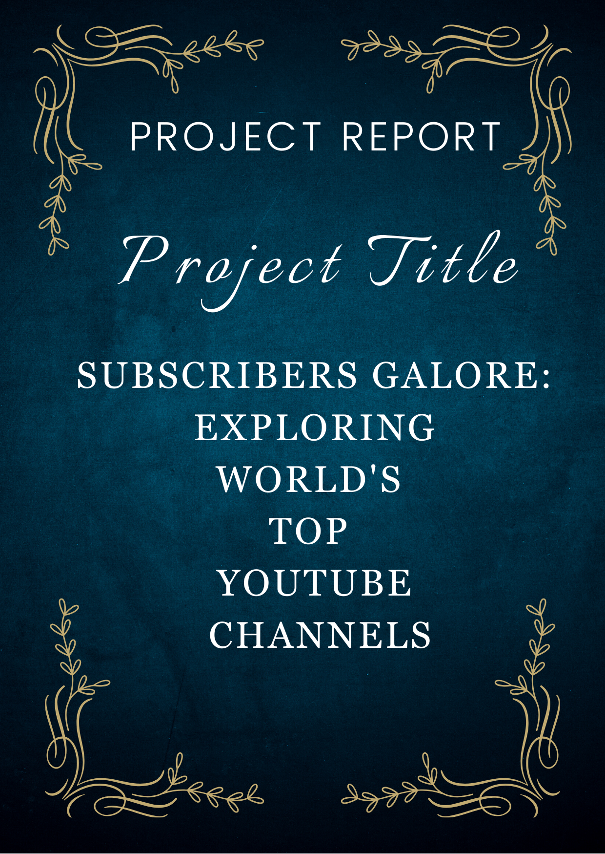

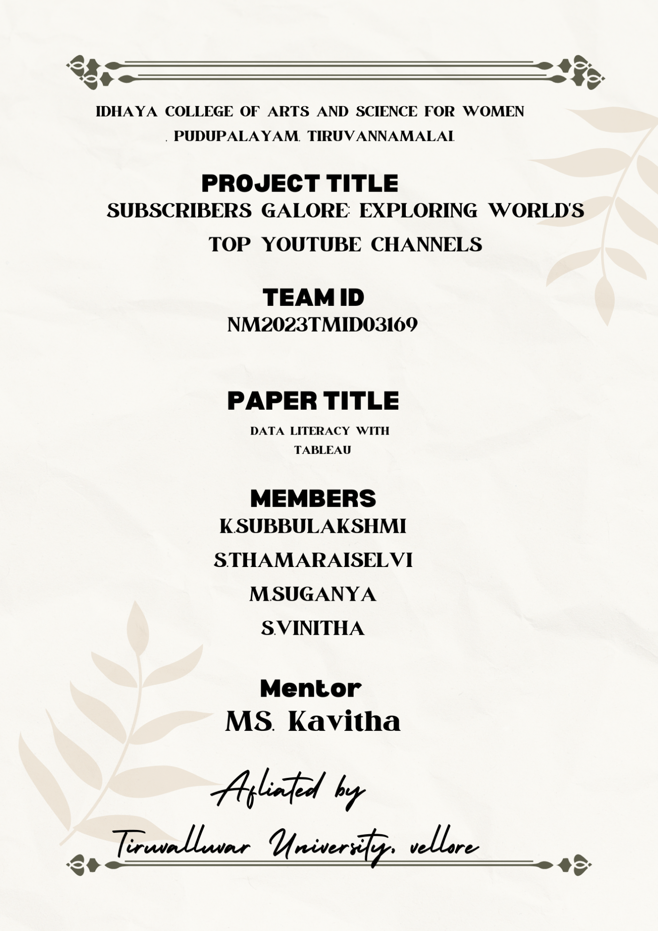

1. *INTRODUCTION*
   1. Overview

Exploring World’sTopYouTube channels. A subscriber to a channel on the video -sharing YouTube is a user who has chosen to receive the channel’s “Subscribe” button, and each user’s subscription feed consists of videos published by channel to which the user is subscribed.

* + - * + The ability to subscribe to users was introduced in October 2005. YouTube began publishing a list of its most-subscribed channels in April 2006.An early archive of the list date to May 2006.
        + The following table lists the 50 most- subscribed YouTube channels, as well as the primary language and content category of each channel.
        + The channels are ordered by number of subscribers; those whose displayed subscriber counts are identical are listed so that the channel whose current growth rate indicates that its displayed subscriber count will exceed that of the other channels is listed
  1. **Purpose**
     + - * The main purpose of you Tube is to provide platform for users of watch, share, and create videos. In the last decade, you Tube has just become the most popular Video-Sharing platform in the world**.**
         * You Tube as an information disseminating platform for students. It’s the perfect place to learn and gain galore.
         * Learn and gain expertise.
         * You Tube’s user-friendliness.
         * You Tube for Brand promotion.
         * You Tube benefits talented people.
         * Easy earning is at the very top of the list of You Tube benefits for vloggers.
         * There are a few main advantages to You Tube for students. It provides access to educational content.
         * Once you subscribe to a channel, any new videos it publishes will show up in your subscriptions feed.

* + - * + A You Tuber is a type of social media influencer who uploads or creates videos on the American online video- sharing website You Tube, typically posting to their personal You Tube channel.
        + A You Tube is a type of social media influencer who uploads or creates videos on the American online video-sharing website You Tube, typically posting on their personal You Tube channel.
        + The numbers of You Tube subscribers is essential because it represents the people interested in your content and will return for more.
        + These are also the people who are most likely to share your videos with their social networks. In other words, subscribers represent potential viewers for your future videos.
        + Creative self- expressions. Making videos on You Tube is a great opportunity for creative self-expression.

1. **Problem definition &Design Thinking** 
   1. Empathy map

An empathy map is a collaborative tool teams can use to gain a deeper insight into their customs.

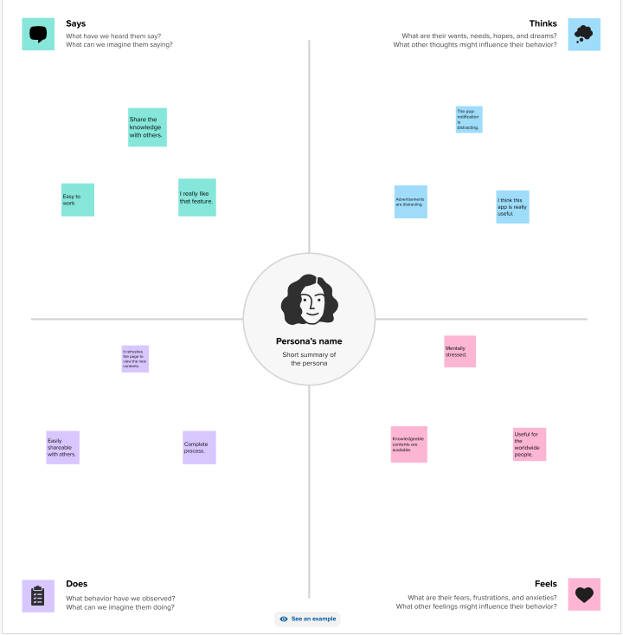

**Ideation and brainstorming Map**

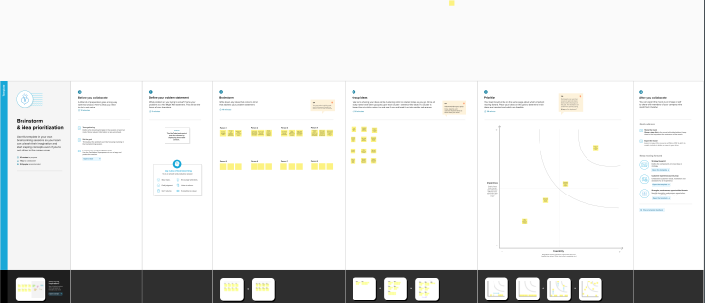

**RESULT**

**A subscribe to a channel on the video-sharing YouTube is a user who has chosen to receive the channels by clicking on the channels subscriber button and each users subscriptions feed consists of videos published by channels to which the user is subscribed.**

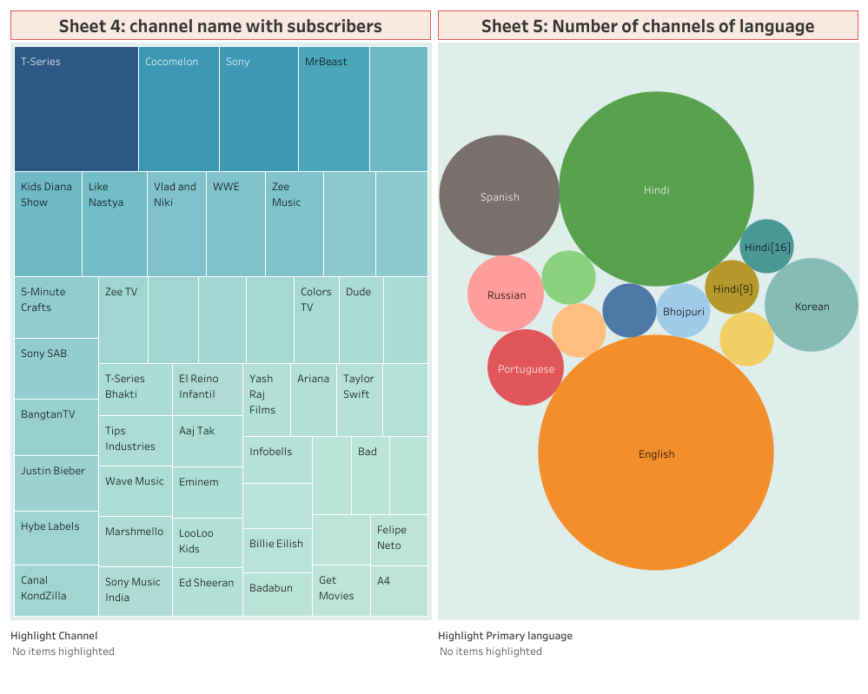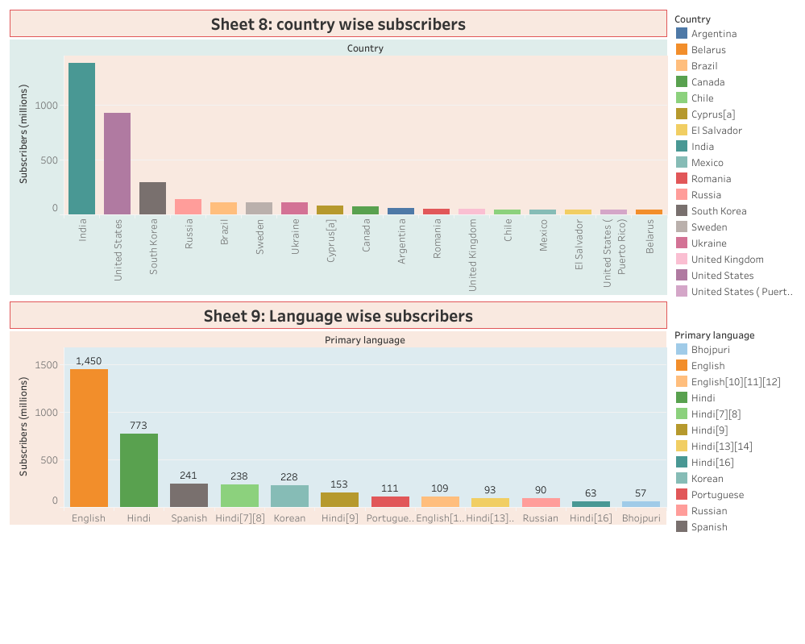

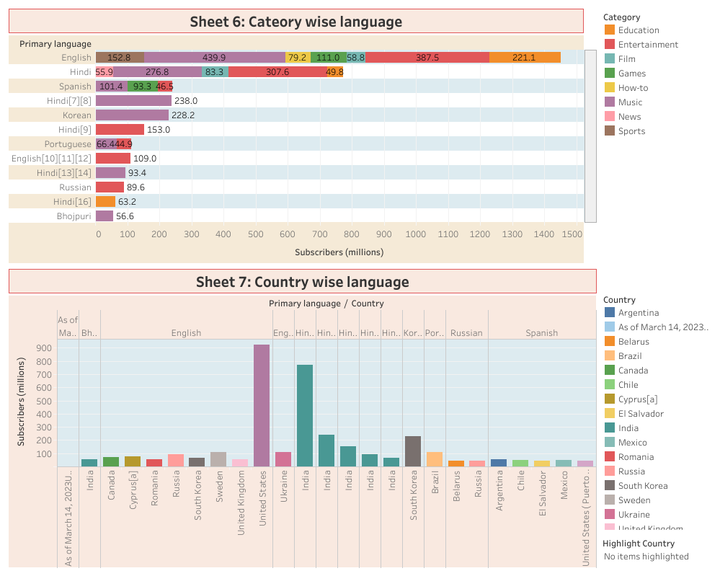

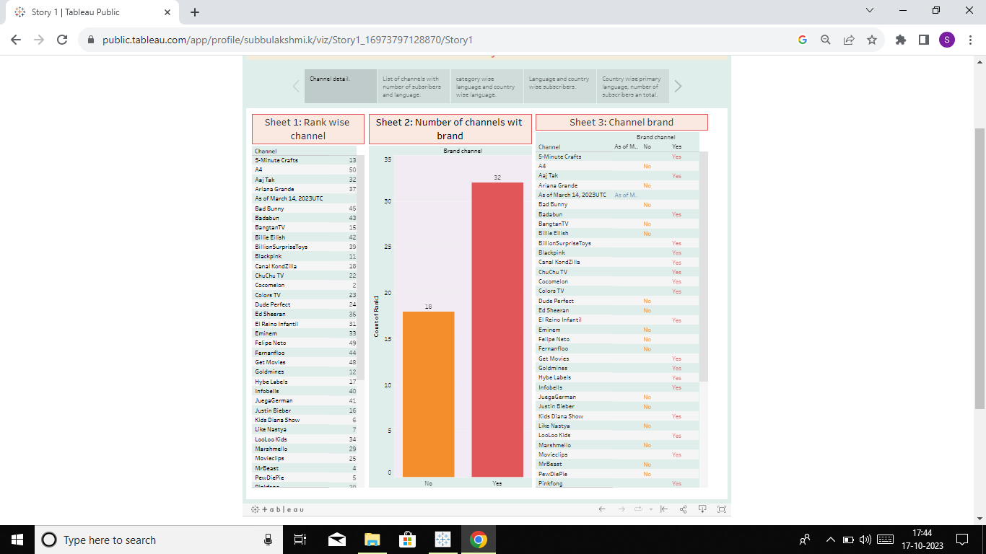

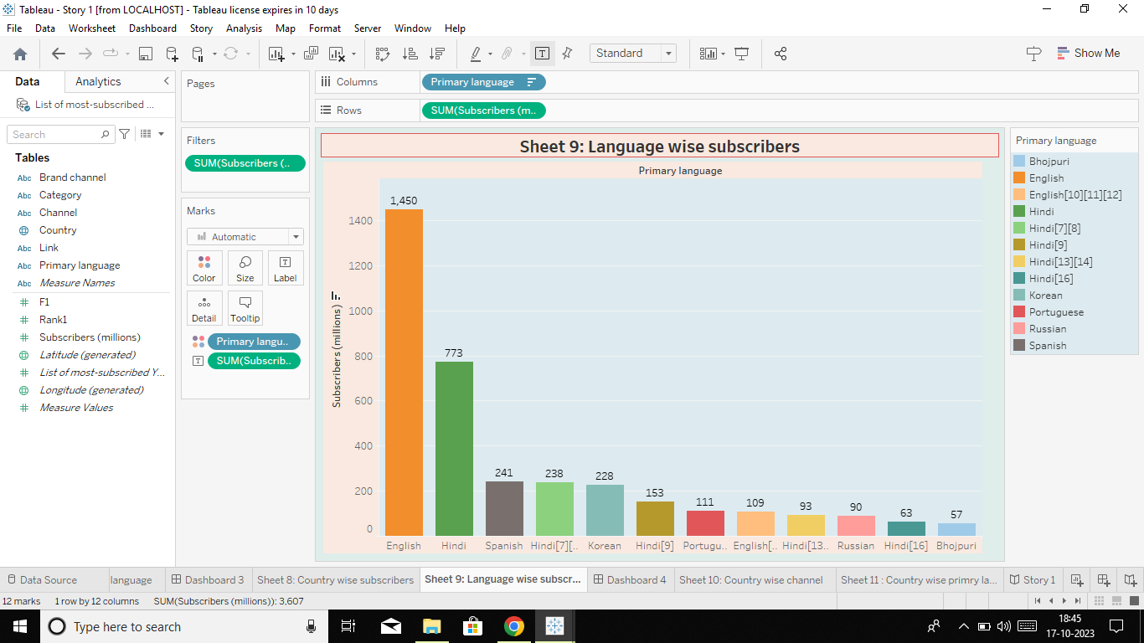

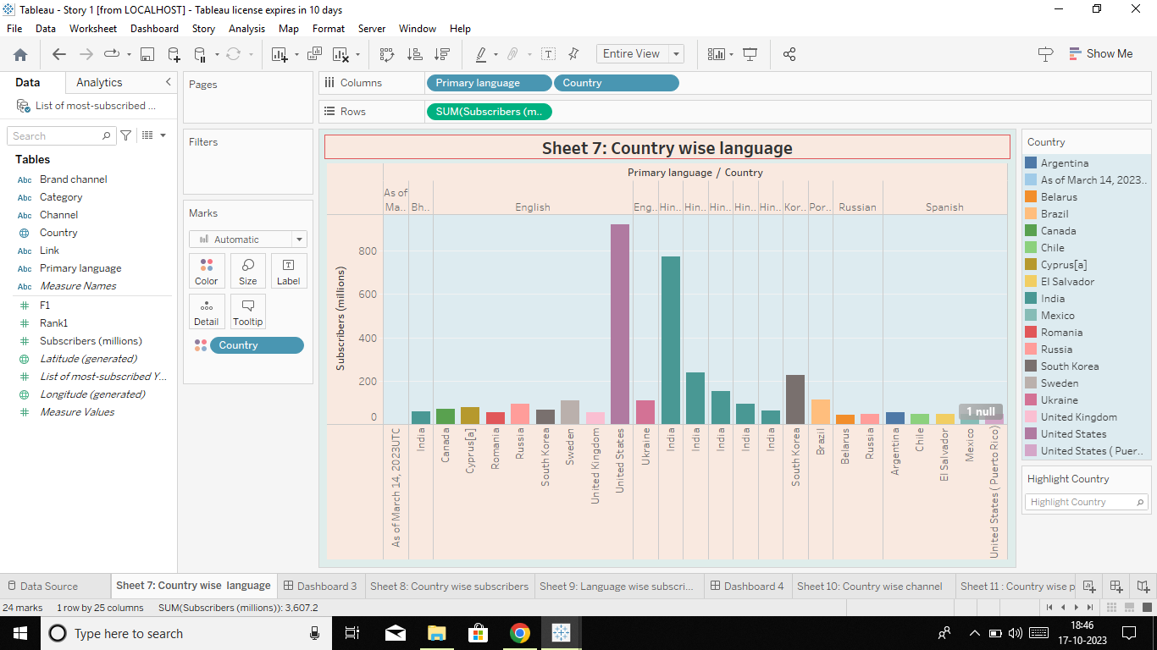

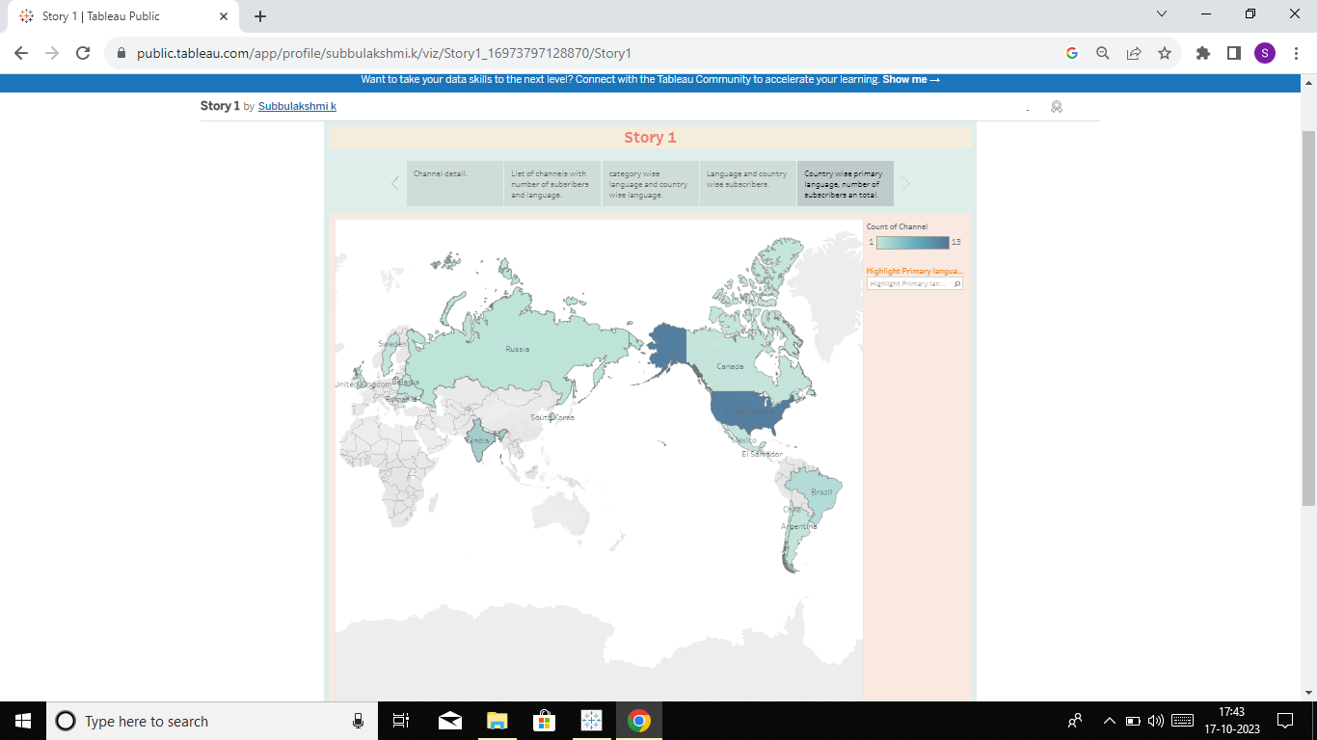

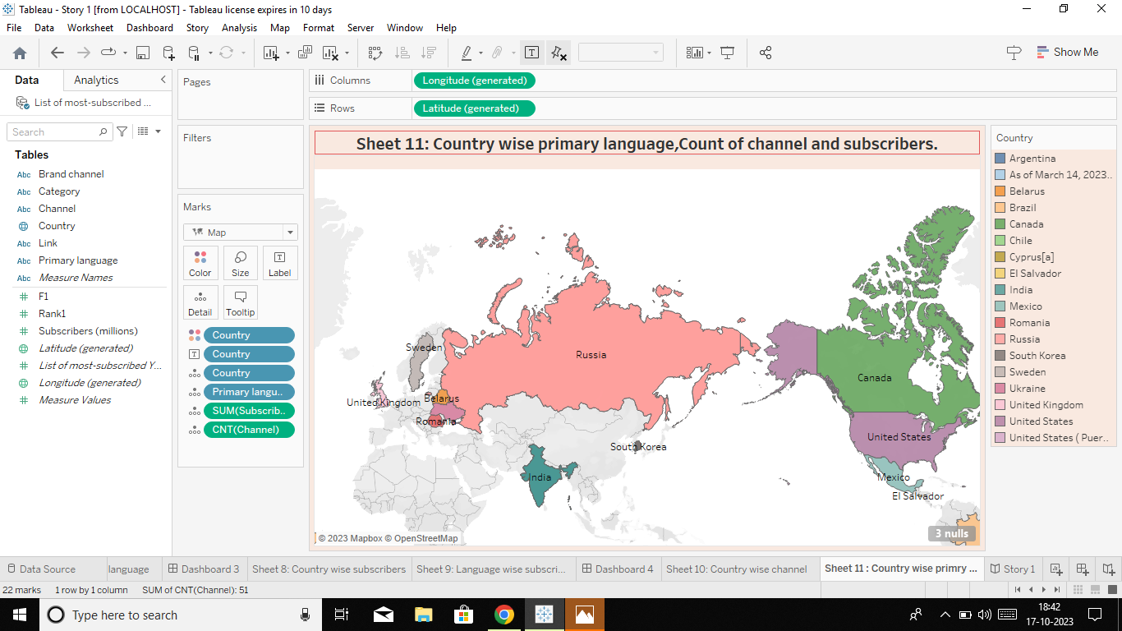

**Advantages and disadvantages**

Advantages

1. YouTube videos are easily shareable and something we recommend you post across your other social media platforms. In turn, this will link back to your YouTube channel and can lead to increased subscribers. You can also embed videos into your web pages and blog posts to help improve bounce rates
2. The combination of visuals and audio — along with YouTube's content culture of simple, digestible messaging makes YouTube videos a great tool for engaging students in learning. In fact, 91% of educational institutions say video increases student satisfaction.

Disadvantages

1. You Tube is drawback of YouTube for the audience advertisement.
2. A lot of distraction. Advertisement.
3. Obscenity- one of the biggest drawbacks that YouTube has. The kind of content that is uploaded on YouTube is largely in control today.
4. Defamation and Bullying.
5. Making money isn't that easy.

**CONCLUSION**

1. Subscribe to a channel you like to see more content from those channels. You can find a subscribe button under any You Tube video or on a channels page. Once you subscribe to a channel, any new videos it publishes will show up in your subscriptions feed.

**FUTURE SCOPE**

1. It’s a growing market. YouTube is ever changing, whether its borrowing features from other platforms, finding new ways to monetize, or making the platform more accessible to creators and viewers.
2. If YouTube continues on the current path, the future will include more streaming, more ecommerce initiatives, and more immersive experiences
3. YouTube has a great scope I You Tube.

Some Youtubers post just for fun, as a hobby or a

Said hustle, and other make it a full-time career.

1. Choosing to be a YouTuber as a career is a great business idea. It's highly doable, gratifying, and it's never been easier to get started. Still, it can take months or even years of constant struggle before you become a prominent and super famous creator on the platform. So, keep at it and do not despair.
2. So, knowing that creators must learn many different skills and perform all of these tasks, it's easy to see how being a YouTuber could be considered a job. While it is a fun job, it's a difficult one that requires a lot of time and effort.
3. Now we a decade and a half later, with 2.70 billion users, this video sharing site is the second most visited website google and holds a second position in Alexa ranking of websites. There are lot of opportunities in the You Tube.

